Pokemon Meta Fire Red X & Y Walkthrough
First and for all, this game does not have much of a changes from the original Pokemon Fire Red. If you do played the game before, then there’s nothing much you’ll have to know. If you haven’t played the game, yet, then be faithful on a game and play it to have fun.
Well, if you are forgetful, or you have no desire of enjoying it in the first place, then look for a Pokemon Fire Red walkthrough.
Now that being said, I won’t be telling any Fire Red shenanigan on this walkthrough, except some few things (that are relevant to the hack itself).
Okay! First point of change is at the players’ house. Once you step at the front of the door leading outside the house, your Mom will call you and give you an Exp. Share right away. This Exp. Share is set as a Key Item and cannot be equipped to a Pokemon. This Exp. Share is edited to share AUTOMATICALLY any experience your Pokemon received from a battle.
This share is always divided into 2 no matter how many Pokemon you have on your party, so decreasing the team members won’t do a thing.
Next edit would be at the outside of Viridian Forest. From there, you will be approached by Mikee. This Mikee is the hacker of the game, and would try to battle you before you step on Pewter City.
His team is composed of:
- Hoppip (shiny)
Holds a Leftover
Have Splash, Leech Seed, Sleep Powder, and Protect
- Feebas
Holds nothing
Have Slash and Water Pulse
After you successfully defeated him he will spout some nonsense. Don’t mind him and play again LOL. The game will become normal again for a while until you reach Route 9 (Route before Rock Tunnel).
The terrain of the Route is completely changed from a grassy-sloppy terrain to a Sandstorm Valley. The wild Pokemon are also changed to adopt the theme of the new Route. Though, nothing much has changed on the trainers.
Before you enter Rock Tunnel, Mikee will greet you again and will give you a Froakie. This Froakie is always shiny, and is at Lvl 50.
Once you’ve reached the second Underground Tunnel (the Tunnel before Celadon City) Mikee will ambush you there for a battle. His team is composed of Skiploom (shiny), Feebas, Scraggy, Axew, and Larvesta.

Celadon City has few important things that you have to take note.
First, the Gym will start to get a buff from this City. (In this case, Erika) Her team and the other Gym will have 5 to 6 Pokemon from now on, with a customized EV and Movepool.
Second, this is the first time you’ll receive a “Sticker”. To get one, go to the Second Floor of Celadon Mansion and look for Mikee. The first time you talk to him, he will give you a Sticker.
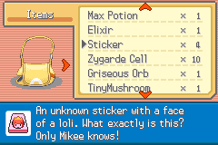
“Sticker” is used to open a “Gashapon”, which contains a Legendary Pokemon
It is a feature on this game.

Third, get the “Tea” from the Old Lady from the First Floor of Celadon. People always forget that LOL.
Once you’ve reached Fuchsia City, remember to go to Safari Zone. While inside, look for the “Key Stone”. Its location is the location where you’re supposed to get the “Gold Teeth”. Once you’ve obtained it to straight to the warden and show the Key Stone. He will give you then the Mega Stone and the HM for Strength.
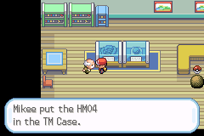

From this point, you are now able to do the Mega Evolution. To do so, equip the Mega Stone to an appropriate Mega Evolving Pokemon. Then, whenever you are on battle, before you select an attack, press START!
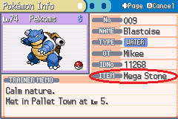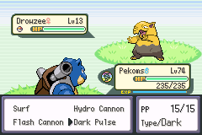
Remember to always press “START” BEFORE YOU PRESS ON AN ATTACK
Your next meeting with Mikee would be at the Bottom Floor of Cinnabar’s Pokemon Mansion. From there, he will battle you with his last team again, with added Axew and an evolved Scrafty. Once you defeated him he will give you another Sticker.
The next change would be on Route 23 before Victory Road. Mikee will battle you again for the last time. His team is composed off: Jumpluff (shiny), Milotic, Scrafty, Volcarona, Haxorus, and Dialga.
Once you’ve defeated him, he will wait for you on Indigo Plateau, where he will give you the Pokemon Cosmog. It is always Lvl 1, and holds Stardust. This Cosmog will evolve according to the version you are playing. If you are playing the X Version, it will evolve into a Cosmoem then a Solgaleo. Otherwise, if you are playing the Y Version, it will be Cosmoem into Lunala. The evolution branch follows the original version.
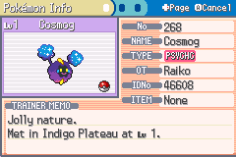
After all that, battle the Elite Four and the Champion and took the crown.
NEXT!
Once you’ve become a Champion, what would you do? Normally, there’s some stuff that you can do. This is a post-game for the FRLG Version. On this version however, if you wanted to do battle the Elite Admins, you are required to do these.
First, fill a 60+ Pokemon entry on your Pokedex to obtain the National Pokedex!
This is simple and self-explanatory. All you have to do is to fill the Dex. Your target here is the National Pokedex. It is required to get to the next event.
Second, collect the Gems for Celio.
You received the Tri-Pass from Bill right? Right when you delivered that Meteorite after you defeated Blaine. Use that! Or if you haven’t, go back to Cinnabar Island and find Bill.
Once you’ve got the Tri-Pass, fly to Vermillion City and sail the ship there. Go to One Island and talk to Celio. Then from there do his errand. Find the Ruby for him. Once you’ve done that bring it back to him and he will give you the Rainbow Pass. Find the Sapphire once you’ve got it and finish his errand. After that you are free to do the next challenge.
Elite Valley
How to go to Elite Valley? After you’ve done the Celio’s event, go to Two Island and find May. She will ask you to battle her there. If you won, she will give you the Elite Pass, which is your invitation card to the grand valley of the elites.
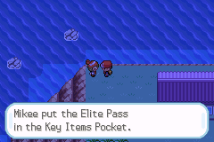

Once you’ve finally got that, go to Seven Islands and look for a path between Trainer Tower and Seven Island. That is where the Elite Valley Entrance is hidden.
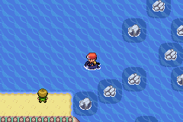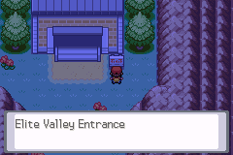
Okay. So once you’re inside, just do what the Admin says. I won’t be spoiling you at this point, but I’m gonna leave a WARNING: REMOVE SOME UNIMPORTANT ITEMS ON YOUR BAG BEFORE YOU DO ANY TRIAL. If your bag is happen to be full when you do the trial, there could be a possibility that you won’t be able to receive the miscellaneous items needed for the trials. Be warned.
Shaharia’s trial
This one’s a little hard. He will tell you to find the Zygarde Cells by your own. How will you find them? Well, if you have investigated the game enough, you’ll notice that there are several familiar faces all around Kanto. If you do not have an idea, well here they are:
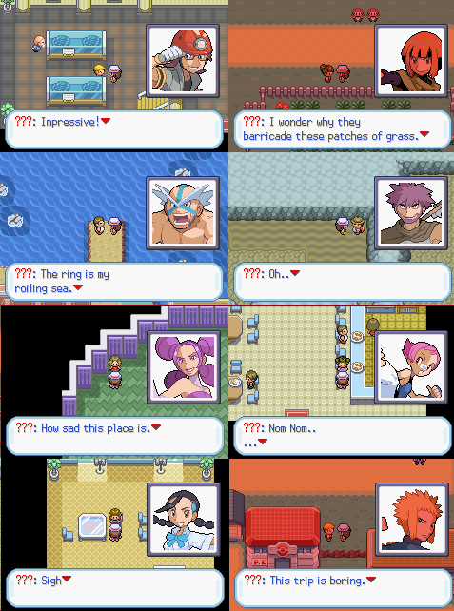
They are the Sinnoh Gym Leaders. They hold the 8 Zygarde Cells. You will only obtain each of it once you’ve defeated them on a Pokemon Battle. Now if you’ve defeated them all, then how about the Tenth Cell? It is located on Mikee’s house on Elite Valley. He’ll tell you the reason why.
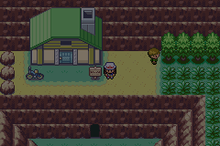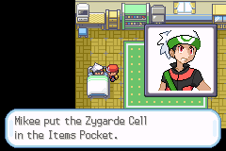
After you are done on Shaharia’s trial, get the Zygarde from the scientist and bring it with you on the cave on Elite Valley.
Arvin’s Trial
This trial is simple. Just talk to him. If you are “approved”, he will give you the Truth Ticket right away.
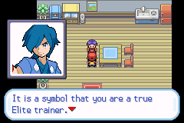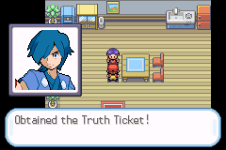
By the way, if you received this message;
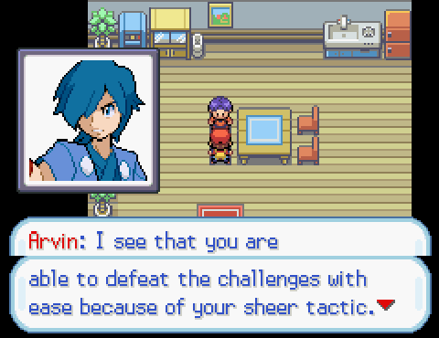
Then that means you are not approved. Don’t worry, though. It is not like you are now stuck or anything. You can still receive the Truth Ticket. You just have to understand what he is saying and what to do. It is Logic Time my friend ;)
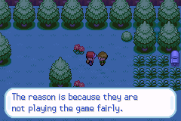
That’s it for the walkthrough. Everything else after this is self-explanatory and easy to understand. All you have to do is read.
There’s also some Easter egg on this game that can only be reached if you are investigative enough.
Well, good luck finding them.
Adios! ;)

